# Lesson 8 Test the line tracking module

Table

1. What do you need to prepare 1

2. Working principle 2

3. Wiring 3

4. Upload the code and test 5

5. Code 8

6. Any questions and suggestions are welcome 9

# 1. What do you need to prepare

|  |  |  |  |
| --- | --- | --- | --- |
| **Components** | **Quantity** | **Picture** | **Remark** |
| USB Cable | 1 |  |  |
| Control board | 1 |  |  |
| Line Tracking module | 1 |  |  |
| 5-Pin wires | 1 |  |  |

# 

# Working principle

"Line Tracking"--- On the white paper with black lines drawn, the black lines can be judged according to the intensity of the reflected light received due to the different reflection coefficients of the black lines and the white paper to light.

A more common detection method, infrared detection method, is used in the line tracking module. Infrared detection method is to use the characteristics of infrared rays that have different reflection properties on physical surfaces of different colors. During the running of the program, infrared light is continuously emitted to the ground. When the infrared light encounters the white ground, diffuse emission occurs, and the reflected light is received by the receiving tube; if it encounters a black line, the infrared light is absorbed, and the receiver of the line tracking module Signal cannot be received. The line tracking module we provide is a three-channel infrared tracking module, which contains 3 sets of sensors, each of which consists of an infrared emitting LED and an infrared receiver.

There are three Reflective Optical Sensors on Line Tracking Module. When the infrared light emitted by infrared diode shines on the surface of different objects, the sensor will receive light with different intensities after reflection.

As we know, black objects absorb light better. So when black lines are drawn on the white plane, the sensor can detect the difference. The sensor can also be called Line Tracking Sensor.

Warning:

Reflective Optical Sensor (including Line Tracking Sensor) should be avoided using in environment with infrared interference, like sunlight. Sunlight contains a lot of invisible light such as infrared and ultraviolet. Under environment with intense sunlight, Reflective Optical Sensor cannot work normally.

# 3. Wiring

Connect the line tracking module to the X1 connector of the Control board with a 5pin cable. The power of the line tracking module is relatively small, it can be powered by the computer with a USB cable, and no external 18650 battery is needed in this lesson.

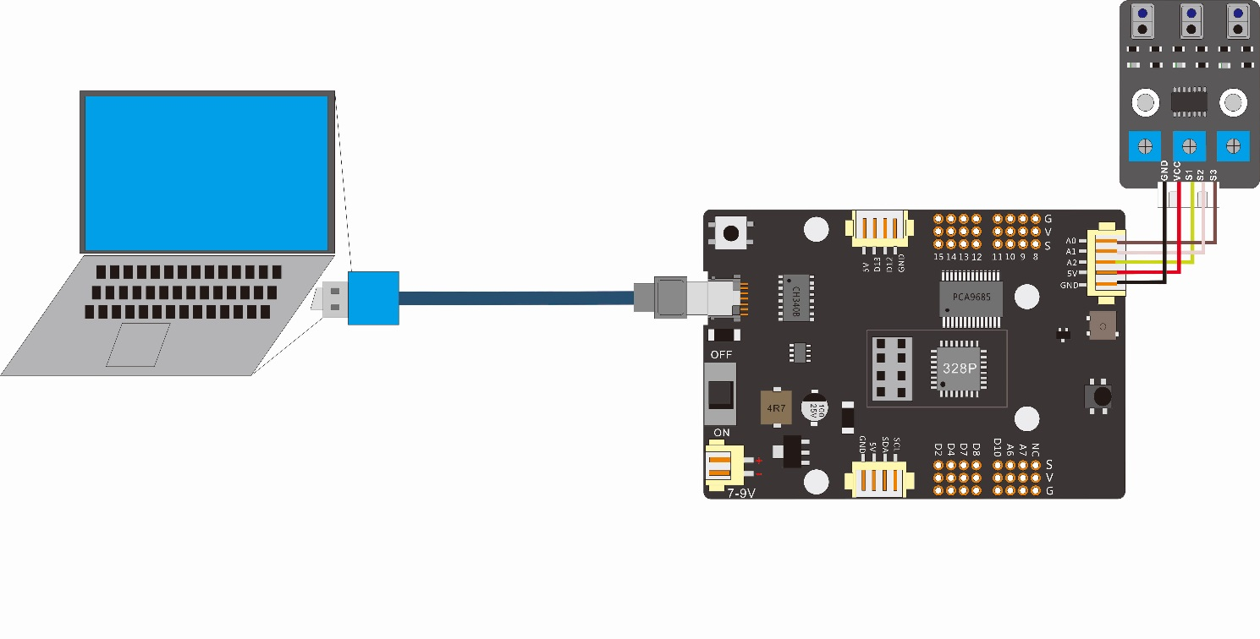

|  |  |
| --- | --- |
| Wiring between the line tracking module and Control board | |
| Connector of the line tracking module | X1 connector of the control board |
| GND | GND |
| VCC | 5V |
| S1 | A2 |
| S2 | A1 |
| S3 | A0 |

White paper with black lines: You can use black tape to stick on the white paper.

# 4. Upload the code and test

The code used in this lesson is placed in this folder：“ E:\CKK0002-master\Tutorial\sketches”

4.1 Double-click the Arduino IDE shortcut on the desktop to open it

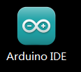

4.2 Click "File" --- "open"

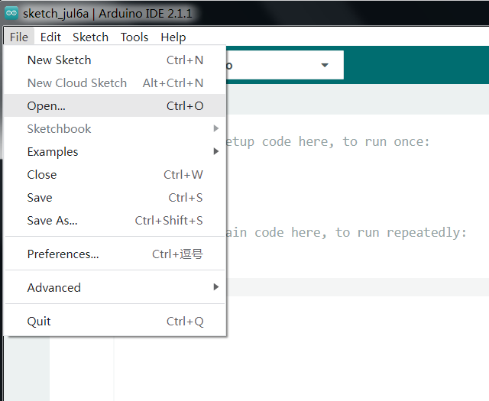

4.3 Select the code in the folder named 6_1_Line_tracking_test：

E:\CKK0002-master\Tutorial\sketches\6_1_Line_tracking_test

Then click "open".

4.4 Select the board "Arduino UNO"and Port "COM3" (COM port is commonly known as an input output port for a device normally PC which enables communication between Arduino and PC. You can check your arduino com number in device manager, the com port of our arduino board is recognized as COM3 in this tutorial)

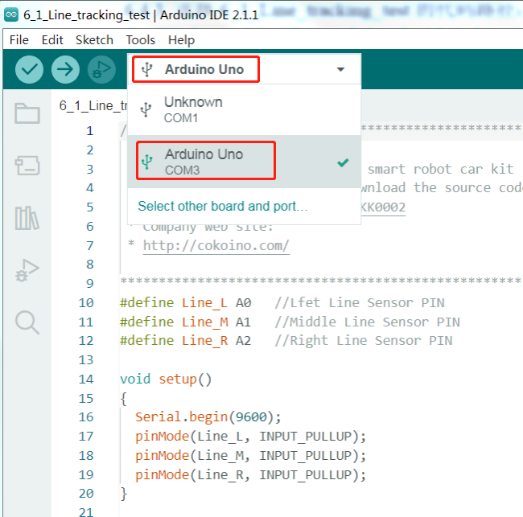

4.5 Click compile button，successfully compiled the code will display “Done compiling”

4.6 Before uploading the code, turn the ESP-01 switch on the control board to the side away from the "ESP-01" silk screen.

4.7 Click upload button，successfully uploading the code will display “Done uploading”. When code is uploaded successfully, the program starts to run.

* 1. Click “Serial Monitor”, you can see the 3 sets of sensor sensing results printed out by the monitor.

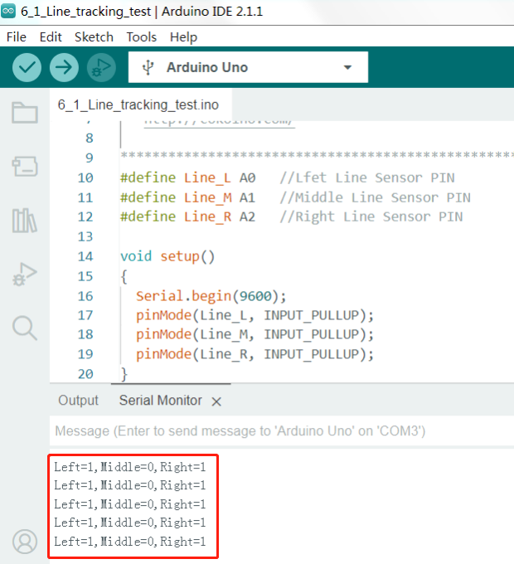

"1": The line tracking module detects a "black line", indicating that the infrared receiver does not receive data. The light from the infrared emitter is absorbed by the black lines.

"0": The line tracking module does not detect the "black line", which means that the infrared receiver has received the light from the infrared transmitter.

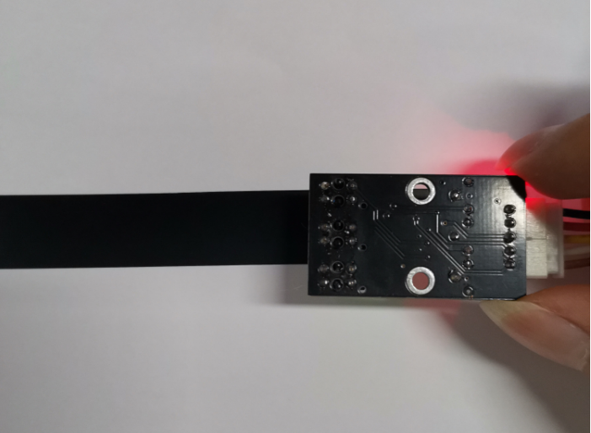

**Note**: If the test result is not satisfactory, you can try to fine-tune the blue potentiometer of the tracking module.

Adjustment method: Connect the Line tracking module and control board with a 5-pin wire, and connect the control board to the computer via a USB cable for power supply. Then, use a screwdriver to rotate the blue potential of the tracking module. Clockwise rotation can improve the sensitivity of the infrared receiver, while counterclockwise rotation can reduce sensitivity, as shown in the following figure.

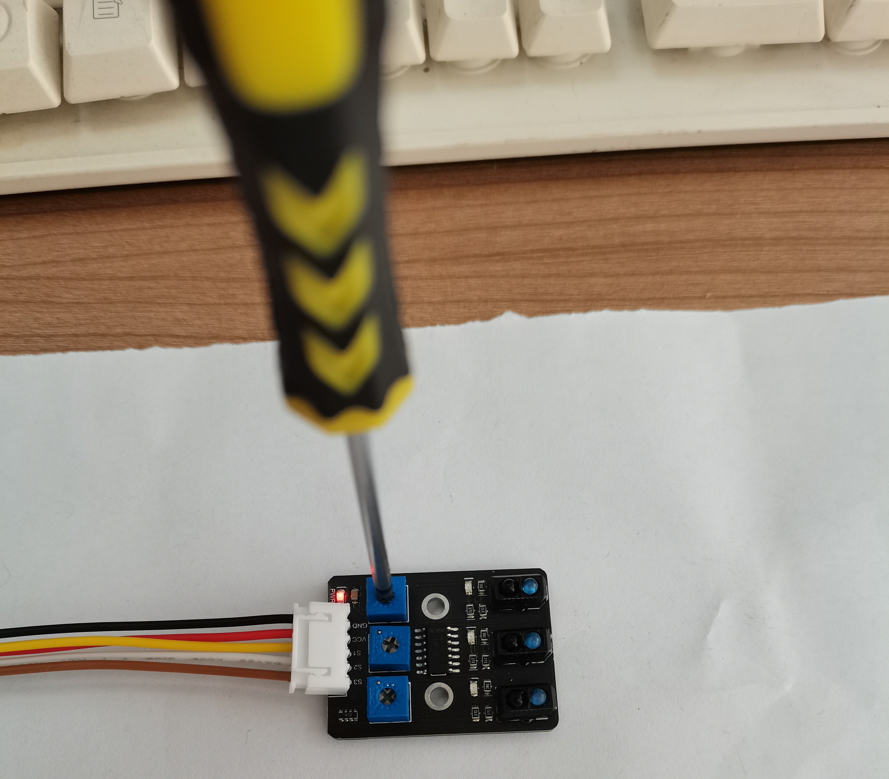

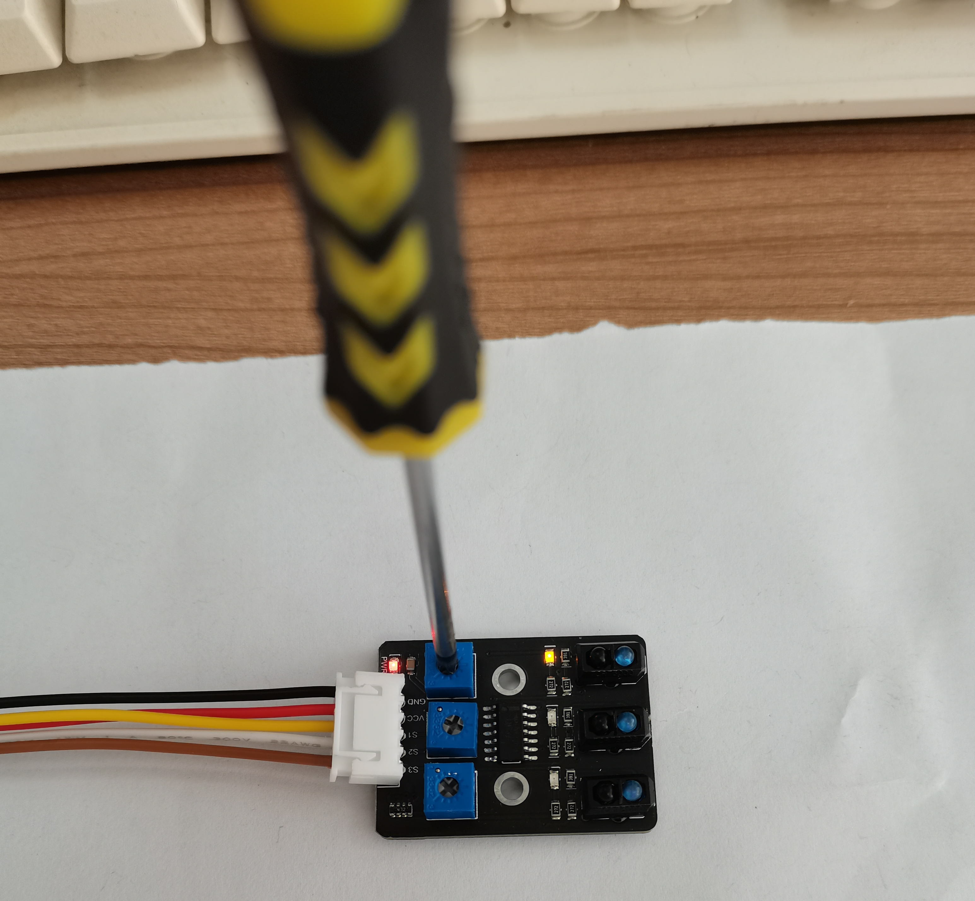

# 5. Code

6_1_Line_tracking_test.ino

#define Line_L A0   //Lfet Line Sensor PIN

#define Line_M A1   //Middle Line Sensor PIN

#define Line_R A2   //Right Line Sensor PIN

void setup()

{

  Serial.begin(9600);

  pinMode(Line_L, INPUT_PULLUP);

  pinMode(Line_M, INPUT_PULLUP);

  pinMode(Line_R, INPUT_PULLUP);

}

void loop()

{

  bool Left_Value = digitalRead(Line_L);

  bool Middle_Value = digitalRead(Line_M);

  bool Right_Value = digitalRead(Line_R);

  delay(200);

  Serial. print(String("Left=") + Left_Value +",");

  Serial. print(String("Middle=") + Middle_Value +",");

  Serial. println(String("Right=") + Right_Value);

}

# 6. Any questions and suggestions are welcome

Thank you for reading this document!

If you find any errors and omissions in the tutorial, or if you have any suggestions and questions, please feel free to contact us:

[cokoino@outlook.com](mailto:cokoino@outlook.com)

We will do our best to make changes and publish revisions as soon as possible.

If you want to learn more about smart cars, robots, learning kits and other technology products from us, please bookmark and pay attention to our website:

<http://cokoino.com/>

We will continue to launch interesting, cost-effective, innovative, user-friendly products.

LK COKOINO